CREATE DATABASE data_bank;

REGIONS TABLE

CREATE TABLE data_bank.dbo.regions (

region_id INTEGER,

region_name VARCHAR(9)

);

CUSTOMER NODES TABLE

CREATE TABLE data_bank.dbo.customer_nodes (

customer_id INTEGER,

region_id INTEGER,

node_id INTEGER,

start_date DATE,

end_date DATE

);

CUSTOMER TRANSACTIONS TABLE

CREATE TABLE data_bank.dbo.customer_transactions (

customer_id INTEGER,

txn_date DATE,

txn_type VARCHAR(10),

txn_amount INTEGER

);

1)

SELECT COUNT(DISTINCT node_id) AS unique_nodes

FROM customer_nodes;

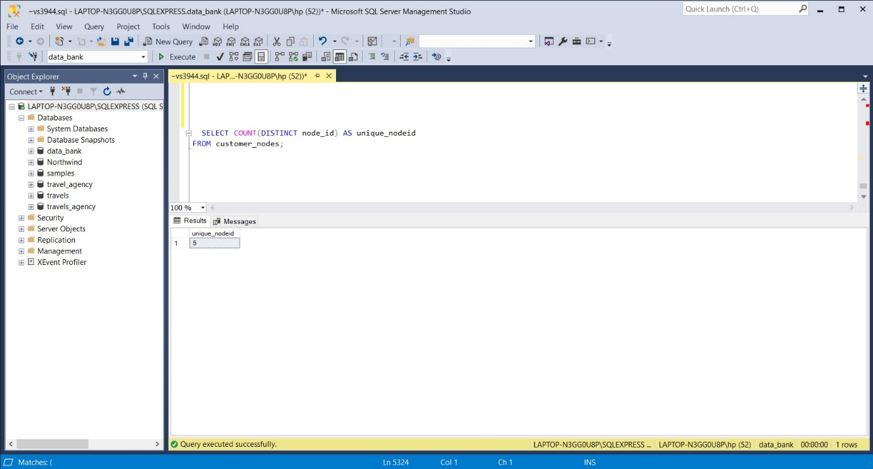

2)

SELECT

r.region_id,

r.region_name,

COUNT(n.node_id) AS nodes

FROM customer_nodes n

JOIN regions r

ON n.region_id = r.region_id

GROUP BY r.region_id, r.region_name

ORDER BY r.region_id;

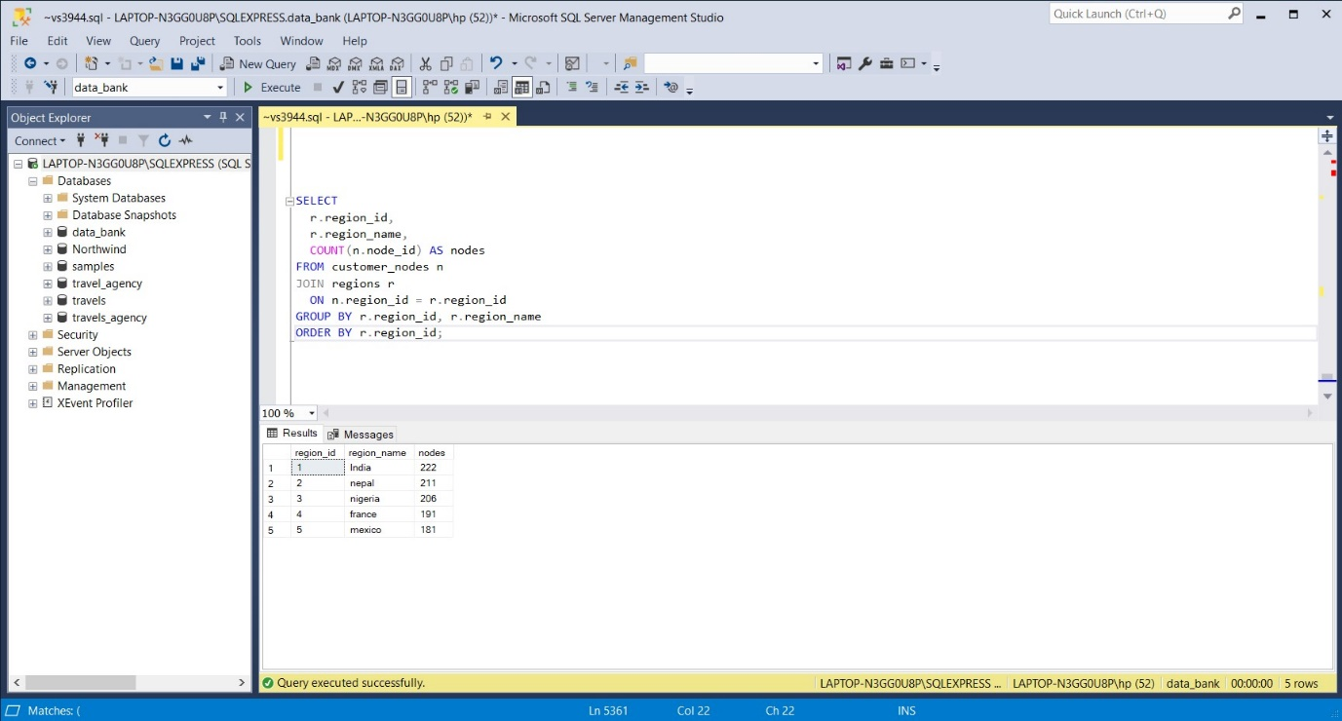

3)

SELECT

r.region_id,

r.region_name,

COUNT(DISTINCT n.customer_id) AS customers

FROM customer_nodes n

JOIN regions r

ON n.region_id = r.region_id

GROUP BY r.region_id, r.region_name

ORDER BY r.region_id;

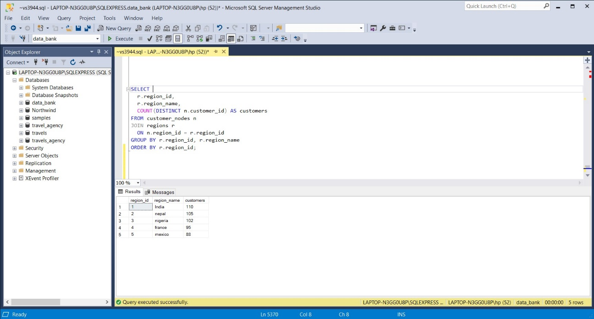

4)

WITH customerDates AS (

SELECT

customer_id,

region_id,

node_id,

MIN(start_date) AS first_date

FROM customer_nodes

GROUP BY customer_id, region_id, node_id

),

reallocation AS (

SELECT

customer_id,

node_id,

region_id,

first_date,

DATEDIFF(DAY, first_date,

LEAD(first_date) OVER(PARTITION BY customer_id

ORDER BY first_date)) AS moving_days

FROM customerDates

)

SELECT

AVG(CAST(moving_days AS FLOAT)) AS avg_moving_days

FROM reallocation;

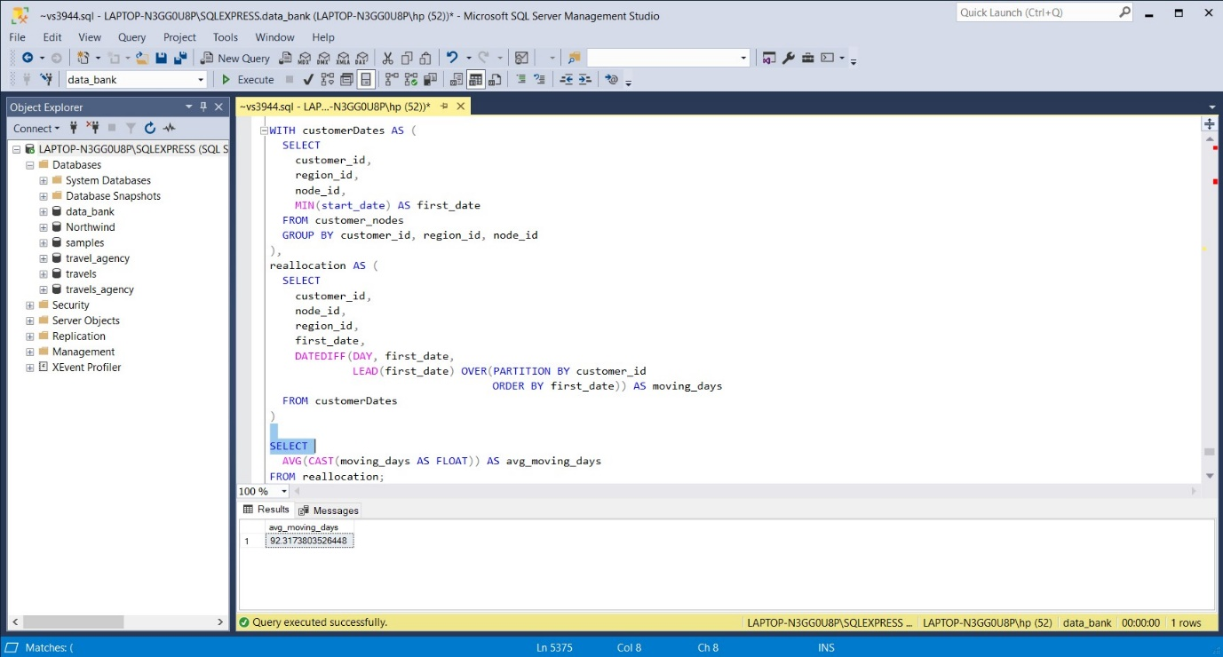

5)

WITH customerDates AS (

SELECT

customer_id,

region_id,

node_id,

MIN(start_date) AS first_date

FROM customer_nodes

GROUP BY customer_id, region_id, node_id

),

reallocation AS (

SELECT

customer_id,

region_id,

node_id,

first_date,

DATEDIFF(DAY, first_date,

LEAD(first_date) OVER(PARTITION BY customer_id

ORDER BY first_date)) AS moving_days

FROM customerDates

)

SELECT

DISTINCT r.region_id,

rg.region_name,

PERCENTILE_CONT(0.5) WITHIN GROUP (ORDER BY r.moving_days) OVER(PARTITION BY r.region_id) AS median,

PERCENTILE_CONT(0.8) WITHIN GROUP (ORDER BY r.moving_days) OVER(PARTITION BY r.region_id) AS percentile_80,

PERCENTILE_CONT(0.95) WITHIN GROUP (ORDER BY r.moving_days) OVER(PARTITION BY r.region_id) AS percentile_95

FROM reallocation r

JOIN regions rg ON r.region_id = rg.region_id

WHERE moving_days IS NOT NULL;

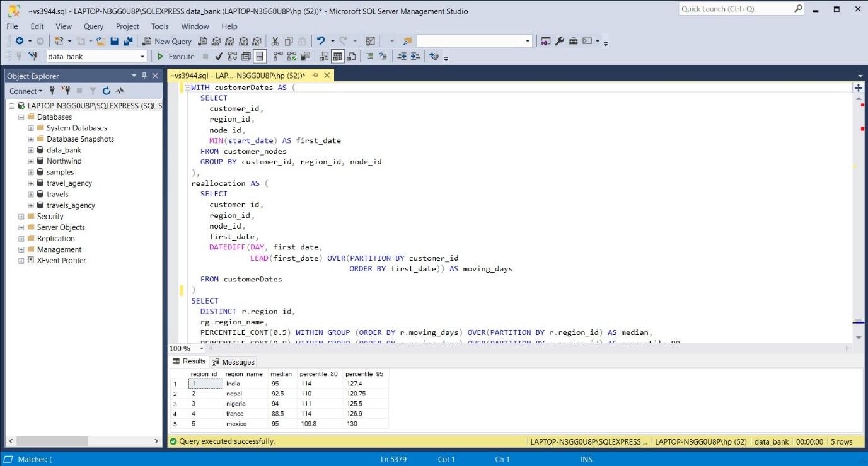

6)

SELECT

txn_type,

COUNT(*) AS unique_count,

SUM(txn_amount) AS total_amount

FROM customer_transactions

GROUP BY txn_type;

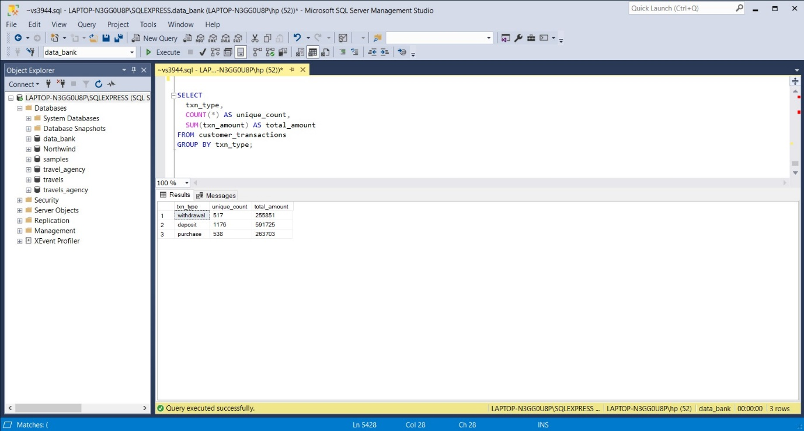

7)

WITH customerDeposit AS (

SELECT

customer_id,

txn_type,

COUNT(*) AS dep_count,

SUM(txn_amount) AS dep_amount

FROM customer_transactions

WHERE txn_type = 'deposit'

GROUP BY customer_id, txn_type

)

SELECT

AVG(dep_count) AS avg_dep_count,

AVG(dep_amount) AS avg_dep_amount

FROM customerDeposit;

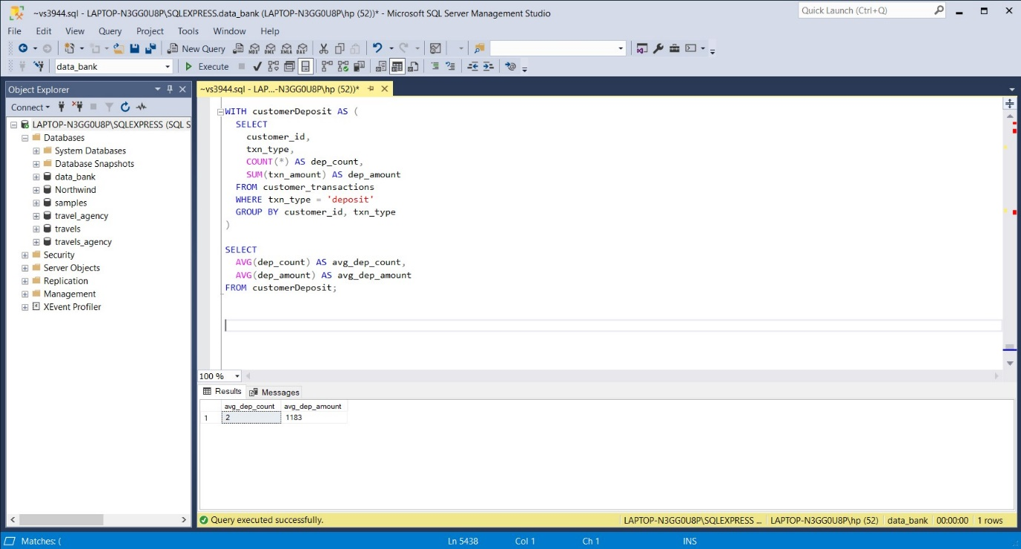

8)

WITH cte_transaction AS (

SELECT

customer_id,

MONTH(txn_date) AS months,

SUM(CASE WHEN txn_type = 'deposit' THEN 1 ELSE 0 END) AS deposit_count,

SUM(CASE WHEN txn_type = 'purchase' THEN 1 ELSE 0 END) AS purchase_count,

SUM(CASE WHEN txn_type = 'withdrawal' THEN 1 ELSE 0 END) AS withdrawal_count

FROM customer_transactions

GROUP BY customer_id, MONTH(txn_date)

)

SELECT

months,

COUNT(customer_id) AS customer_count

FROM cte_transaction

WHERE deposit_count > 1

AND (purchase_count = 1 OR withdrawal_count = 1)

GROUP BY months;

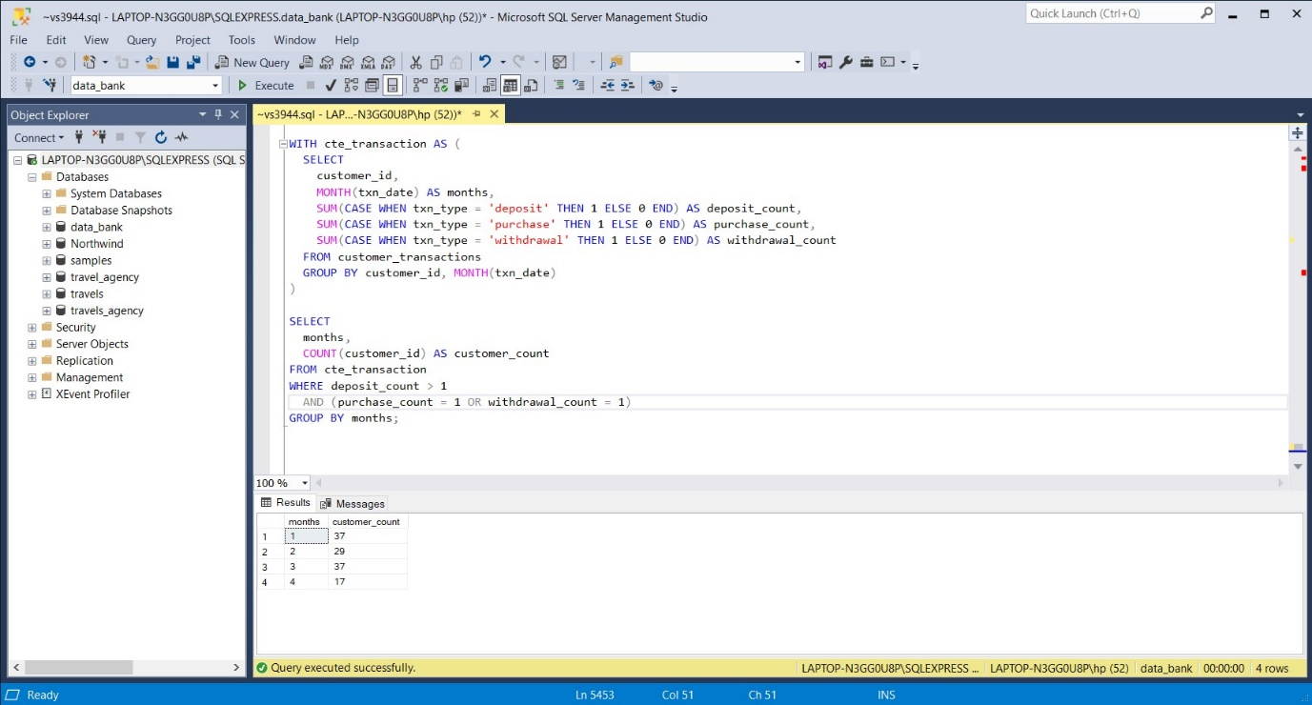

9)

--End date in the month of the max date of our dataset

DECLARE @maxDate DATE;

SET @maxDate = (SELECT EOMONTH(MAX(txn_date)) FROM customer_transactions);

--CTE 1: Monthly transactions of each customer

WITH monthly_transactions AS (

SELECT

customer_id,

EOMONTH(txn_date) AS end_date,

SUM(CASE WHEN txn_type IN ('withdrawal', 'purchase') THEN -txn_amount

ELSE txn_amount END) AS transactions

FROM customer_transactions

GROUP BY customer_id, EOMONTH(txn_date)

),

--CTE 2: Increment last days of each month till they are equal to @maxDate

recursive_dates AS (

SELECT

DISTINCT customer_id,

CAST('2020-01-31' AS DATE) AS end_date

FROM customer_transactions

UNION ALL

SELECT

customer_id,

EOMONTH(DATEADD(MONTH, 1, end_date)) AS end_date

FROM recursive_dates

WHERE EOMONTH(DATEADD(MONTH, 1, end_date)) <= @maxDate

)

SELECT

r.customer_id,

r.end_date,

COALESCE(m.transactions, 0) AS transactions,

SUM(m.transactions) OVER (PARTITION BY r.customer_id ORDER BY r.end_date

ROWS UNBOUNDED PRECEDING) AS closing_balance

FROM recursive_dates r

LEFT JOIN monthly_transactions m

ON r.customer_id = m.customer_id

AND r.end_date = m.end_date;

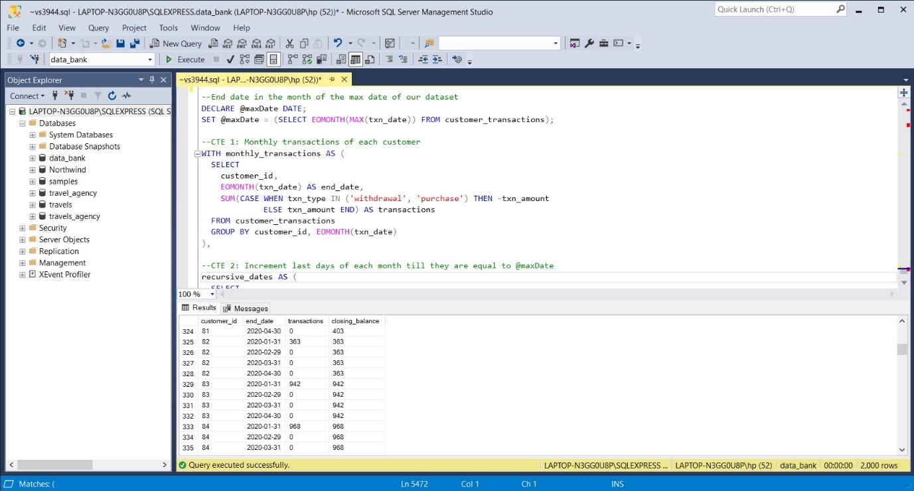

10)

--End date in the month of the max date of our dataset (Q4)

DECLARE @maxDate DATE;

SET @maxDate = (SELECT EOMONTH(MAX(txn_date)) FROM customer_transactions);

--CTE 1: Monthly transactions of each customer (Q4)

WITH monthly_transactions AS (

SELECT

customer_id,

EOMONTH(txn_date) AS end_date,

SUM(CASE WHEN txn_type IN ('withdrawal', 'purchase') THEN -txn_amount

ELSE txn_amount END) AS transactions

FROM customer_transactions

GROUP BY customer_id, EOMONTH(txn_date)

),

--CTE 2: Increment last days of each month till they are equal to @maxDate (Q4)

recursive_dates AS (

SELECT

DISTINCT customer_id,

CAST('2020-01-31' AS DATE) AS end_date

FROM customer_transactions

UNION ALL

SELECT

customer_id,

EOMONTH(DATEADD(MONTH, 1, end_date)) AS end_date

FROM recursive_dates

WHERE EOMONTH(DATEADD(MONTH, 1, end_date)) <= @maxDate

),

-- CTE 3: Closing balance of each customer by monthly (Q4)

customers_balance AS (

SELECT

r.customer_id,

r.end_date,

COALESCE(m.transactions, 0) AS transactions,

SUM(m.transactions) OVER (PARTITION BY r.customer_id ORDER BY r.end_date

ROWS UNBOUNDED PRECEDING) AS closing_balance

FROM recursive_dates r

LEFT JOIN monthly_transactions m

ON r.customer_id = m.customer_id

AND r.end_date = m.end_date

),

--CTE 4: CTE 3 & next_balance

customers_next_balance AS (

SELECT *,

LEAD(closing_balance) OVER(PARTITION BY customer_id ORDER BY end_date) AS next_balance

FROM customers_balance

),

--CTE 5: Calculate the increase percentage of closing balance for each customer

pct_increase AS (

SELECT *,

100.0*(next_balance-closing_balance)/closing_balance AS pct

FROM customers_next_balance

WHERE closing_balance ! = 0 AND next_balance IS NOT NULL

)

--Create a temporary table because of the error: Null value is eliminated by an aggregate or other SET operation

SELECT *

INTO #temp

FROM pct_increase;

--Calculate the percentage of customers whose closing balance increasing 5% compared to the previous month

SELECT CAST(100.0*COUNT(DISTINCT customer_id) AS FLOAT)

/ (SELECT COUNT(DISTINCT customer_id) FROM customer_transactions) AS pct_customers

FROM #temp

WHERE pct > 5;

